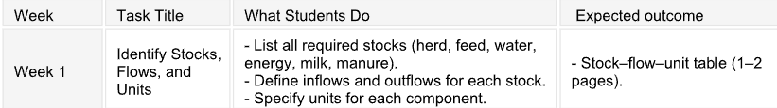

Stock 1: Herd size
- Inflows: birth rate, purchased animals/rate
- Outflows: death rate, culling rate

Stock 2: Feed
- Inflow: feed delivery rate
- Outflow: feed consumption rate, feed spoilage rate

Stock 3: Water
- Inflow: Water supply rate
- Outflow: Water consumption rate, water used in system cooling, sanitation, and irrigation

Stock 4: Energy
- Inflow: Energy supply
- Outflow: Milking system energy, cooling energy, heating, and lighting energy

Stock 5: Milk
- Inflow: Milk production rate
- Outflow: Milk sold, milk spoiled

Stock 6: Manure
- Inflow: Manure production rate
- Outflow: Manure removal rate, manure emission rate, manure degradation rate

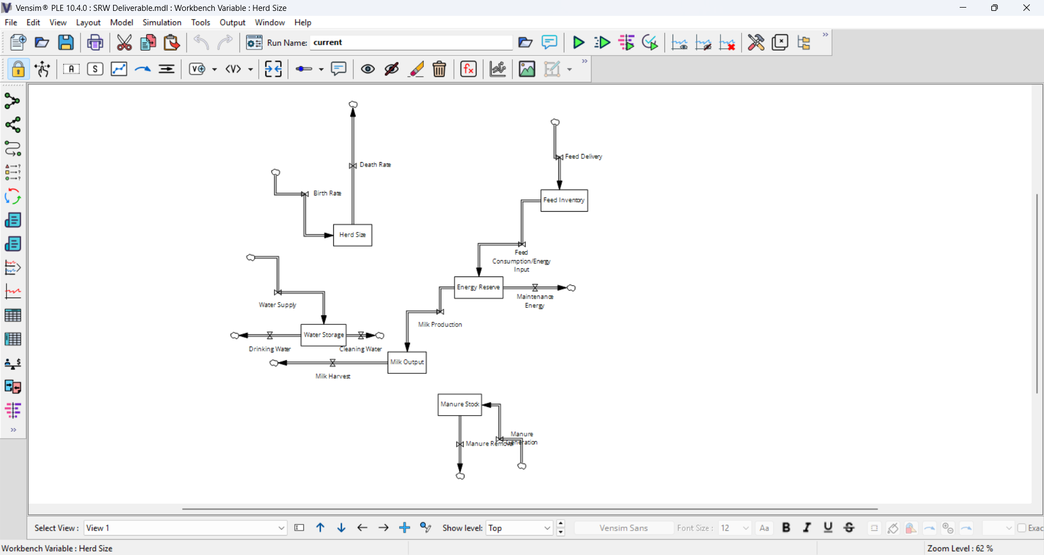
First look ^^^

Only two stocks that point towards each other are feed consumption to energy, and energy to milk production

Need a dynamic hypothesis
Introduction: optimize resources (find the problem and how we are fixing it)
material and method
discussion
results
references

